- I installed maven integration plugin and set the maven in the tools page
- There are 2 types of Hypervisor
  - 1. Type-1 Hypervisor
    - Here, Bottom layer is Hardware, then Hypervisor, then multiple Virtual Machines
    - There is no Host OS in this case. You can imagine as dual-boot as having Type-1 hypervisor.
  - 2. Type-2 Hypervisor
    - Here, bottom layer is Hardware, then Host OS, then Hypervisor then multiple VMs.
    - Ex: Oracle Virtualbox, you can install it on windows (for example) and lunch multiple virtual machines
  - 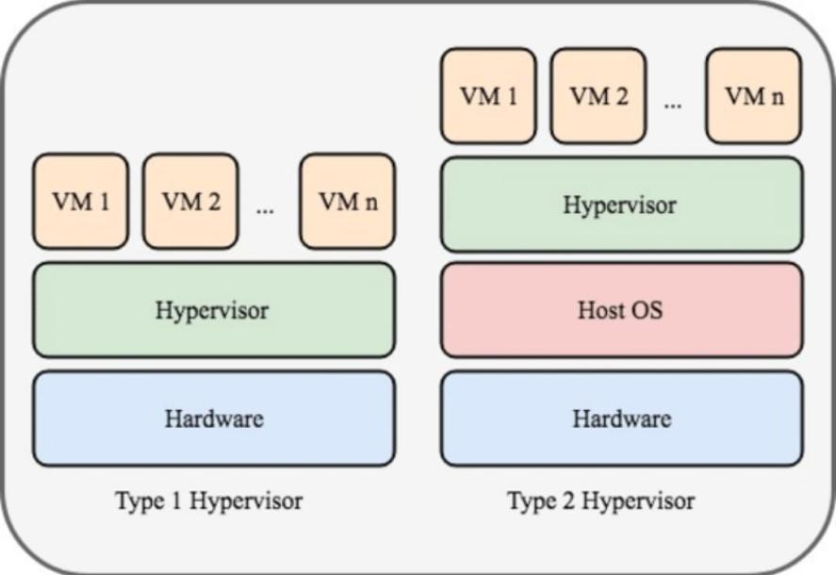
- OS consists of 2 things (in case of no container)
  - Kernel
    - It is the core part which talks to actual hardware.
  - User space
    - It is containing of the systemd, shell, libraries, applications (like node, java ..etc)
- When we hit node server.js the following steps are executed:
  - System call
  - Kernel
  - CPU / Memory / Disk

- Containers
- What happens when we run some application or execute some commands?
  - The kernel loads the binaries first.
  - Lets say you execute node server.js then Kernel will load the binaries; because Kernel doesn’t know anything but the binaries.
  - In normal system (having no containers), the application (node.js in our case) is installed at some directory, Kernel will load that.
  - So, all the thing that Kernel needs the binaries.
  - So, the idea is, why to install those dependencies/applications in our system? Just keep it in some other path and inform Kernel to use the binaries from that path.
    - This is the core idea of Containers.
- Containers
  - The containers only contains the application dependencies, and there is something called as Container Runtime in the VM (VM of host machine where the container will run), that’s tells Kernel to use the Binaries from that path instead of finding in its own System.
  - There is no Container Runtime during the running state of containers, its just there to set the isolation rule before starting the container.
  - Container Runtime doesn’t sit between Application and Kernel.
  - Each container has its own filesystem with its own binaries and dependencies (Node, Java, Maven, etc.).
  - When containers run, the kernel executes binaries from each container’s own filesystem view, because each process has a different filesystem namespace, they cannot see or interfere with each other’s dependencies.
    - namespace means PID, User etc etc.
    - 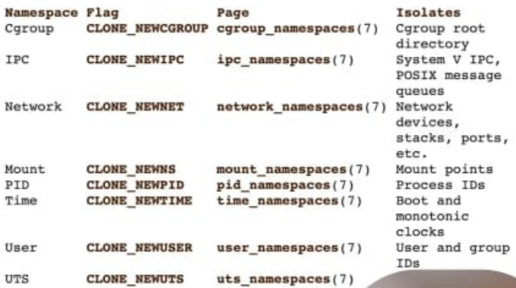
    - Means, the root user inside the container might be some non-root user in the system that is running the container.
    - Application inside the container thinks there is only one process having PID (assigned to itself) is running in the system, but there might be so many processes having different PID running in the systems.
  - 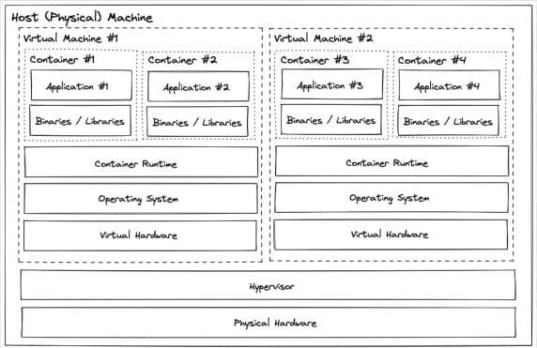
  - The container might be running in the Host only, or any of the VMs running on the Host.
  - The VMs are having their own Kernels (of course because they are having their Own OS and Kernel is a part of OS only)
    - And they are having their own set of Virtual Hardware that are being assigned to them (like Memory, CPU etc)
- What does it mean by Isolation? Every application present inside the container are running just like a different application (like Chrome, Firefox) right?
  - The containers are not having any dedicated Kernels, they share the host kernel.
  - Any 2 containers running doesn’t interfare each other, the have their own set of libraries or dependencies.
  - Kernel will use their versions of libraries and run them. So, there is no dependency collision or something like that.

- Layers in Container
  - A Docker image is made of Layers.
  - Layers are created line-by-line from the Dockerfile
  - Layers are read-only.
  - When a container runs, Docker adds one more extra writable layer on the top.
  - Example:
    - 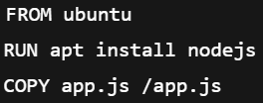 (Dockerfile)
    - This creates layers like
      - Ubuntu layer → base OS files
      - Node.js layer → Node installed
      - App layer → your code
      - Writable layer → created when container starts
  - Why layers exist ?
    - Speed → unchanged layers are reused
    - Less storage → same layers shared by many containers
    - Easy updates → change only the top layer
    - Example: 10 Node.js containers → all share same Node layer, Only app code layer is different
  - Writable layer
    - Containers cannot change image layers
    - Any file write goes to the top writable layer
    - When container is deleted → data is gone;
  - That’s why use volumes to store the data like DB data, logs, uploaded files etc

- Layers before & after runtime (IMPORTANT)
- First thing: Dockerfile can create only one type of Container (can have multiple containers, but all will be identical) if there is no variables are used inside the Dockerfile
  - 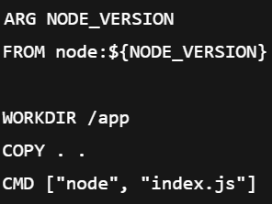
    - In this case, depending upon the NODE_VERSION variable different type of containers can be created (it is different)
  - 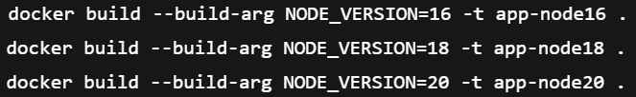
    - You can create different types of containers like this

- How the layers are created and how those are re-used (or shared) ?
  - Consider the below Dockerfile
    - 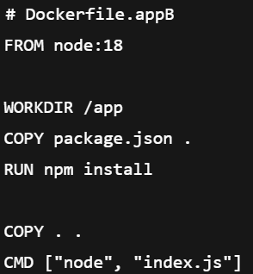
    - Here I the node version 18 is being used.
  - Now you build this docker file using docker build command, Docker will create all the layers.
  - When we run the docker using docker run command.
    - It’ll create layers from each line of this Dockerfile
    - Like Node-18 layer will be present in this case
    - And it’ll store a unique hash of each layer
  - After that, let’s say I executed docker run for this Dockerfile again or for some other Dockerfile that contains Node-18 image again
    - Now again Docker will scan that Dockerfile, and then see there is a layer already present that have Node-18 (checking the hash) and it’ll re-use that layer only, without creating another layer.
  - These all sharing and all are done by Docker (not Kernel)
  - After creating the layers, it’ll ask Kernel for the namespaces like PID, and all
  - Then Kernel will run this.

- Example of this Layer creation
  - Consider this Dockerfile again
    - 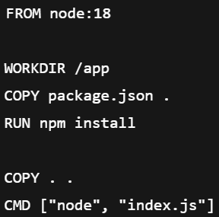
  - Now execute build command
  - Now Docker will creates a IMAGE layers (read-only) (layers are created by docker, not Kernel)
    - 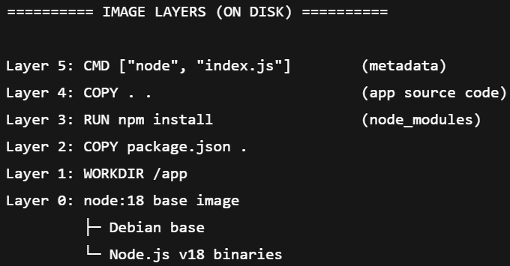
    - These layers are stored once, identified by hashes, read-only,
  - Now execute run command
    - 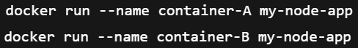
  - Now the layers in the runtime
    - 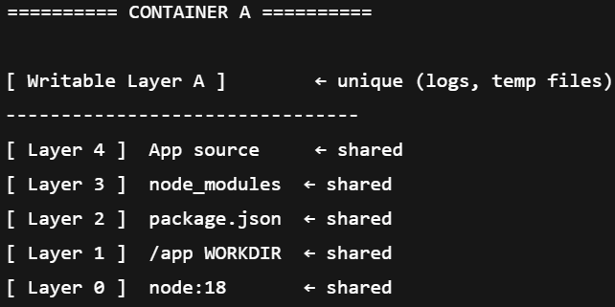
    - 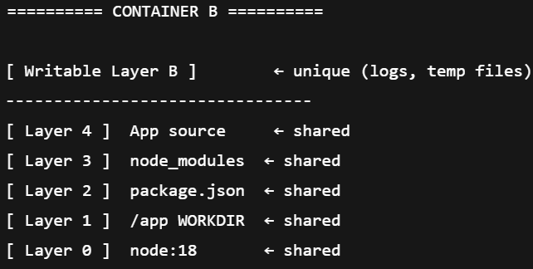
    - All the layers were present, so it is shared now
  - Even if the layers are shared among the containers, but the namespaces (PID, network etc etc) are different for all the containers. Also the writable-layer is unique for all containers.

  - F
  - F
- F
- F
- F
- F
- F

- F
- F
- F
- F
- F
- F
- F
- F
- F
- F
- F
- F
- F
- F
- F
- F
- F
- F
- F

